**United States Department of Agriculture**

Food and Nutrition Service

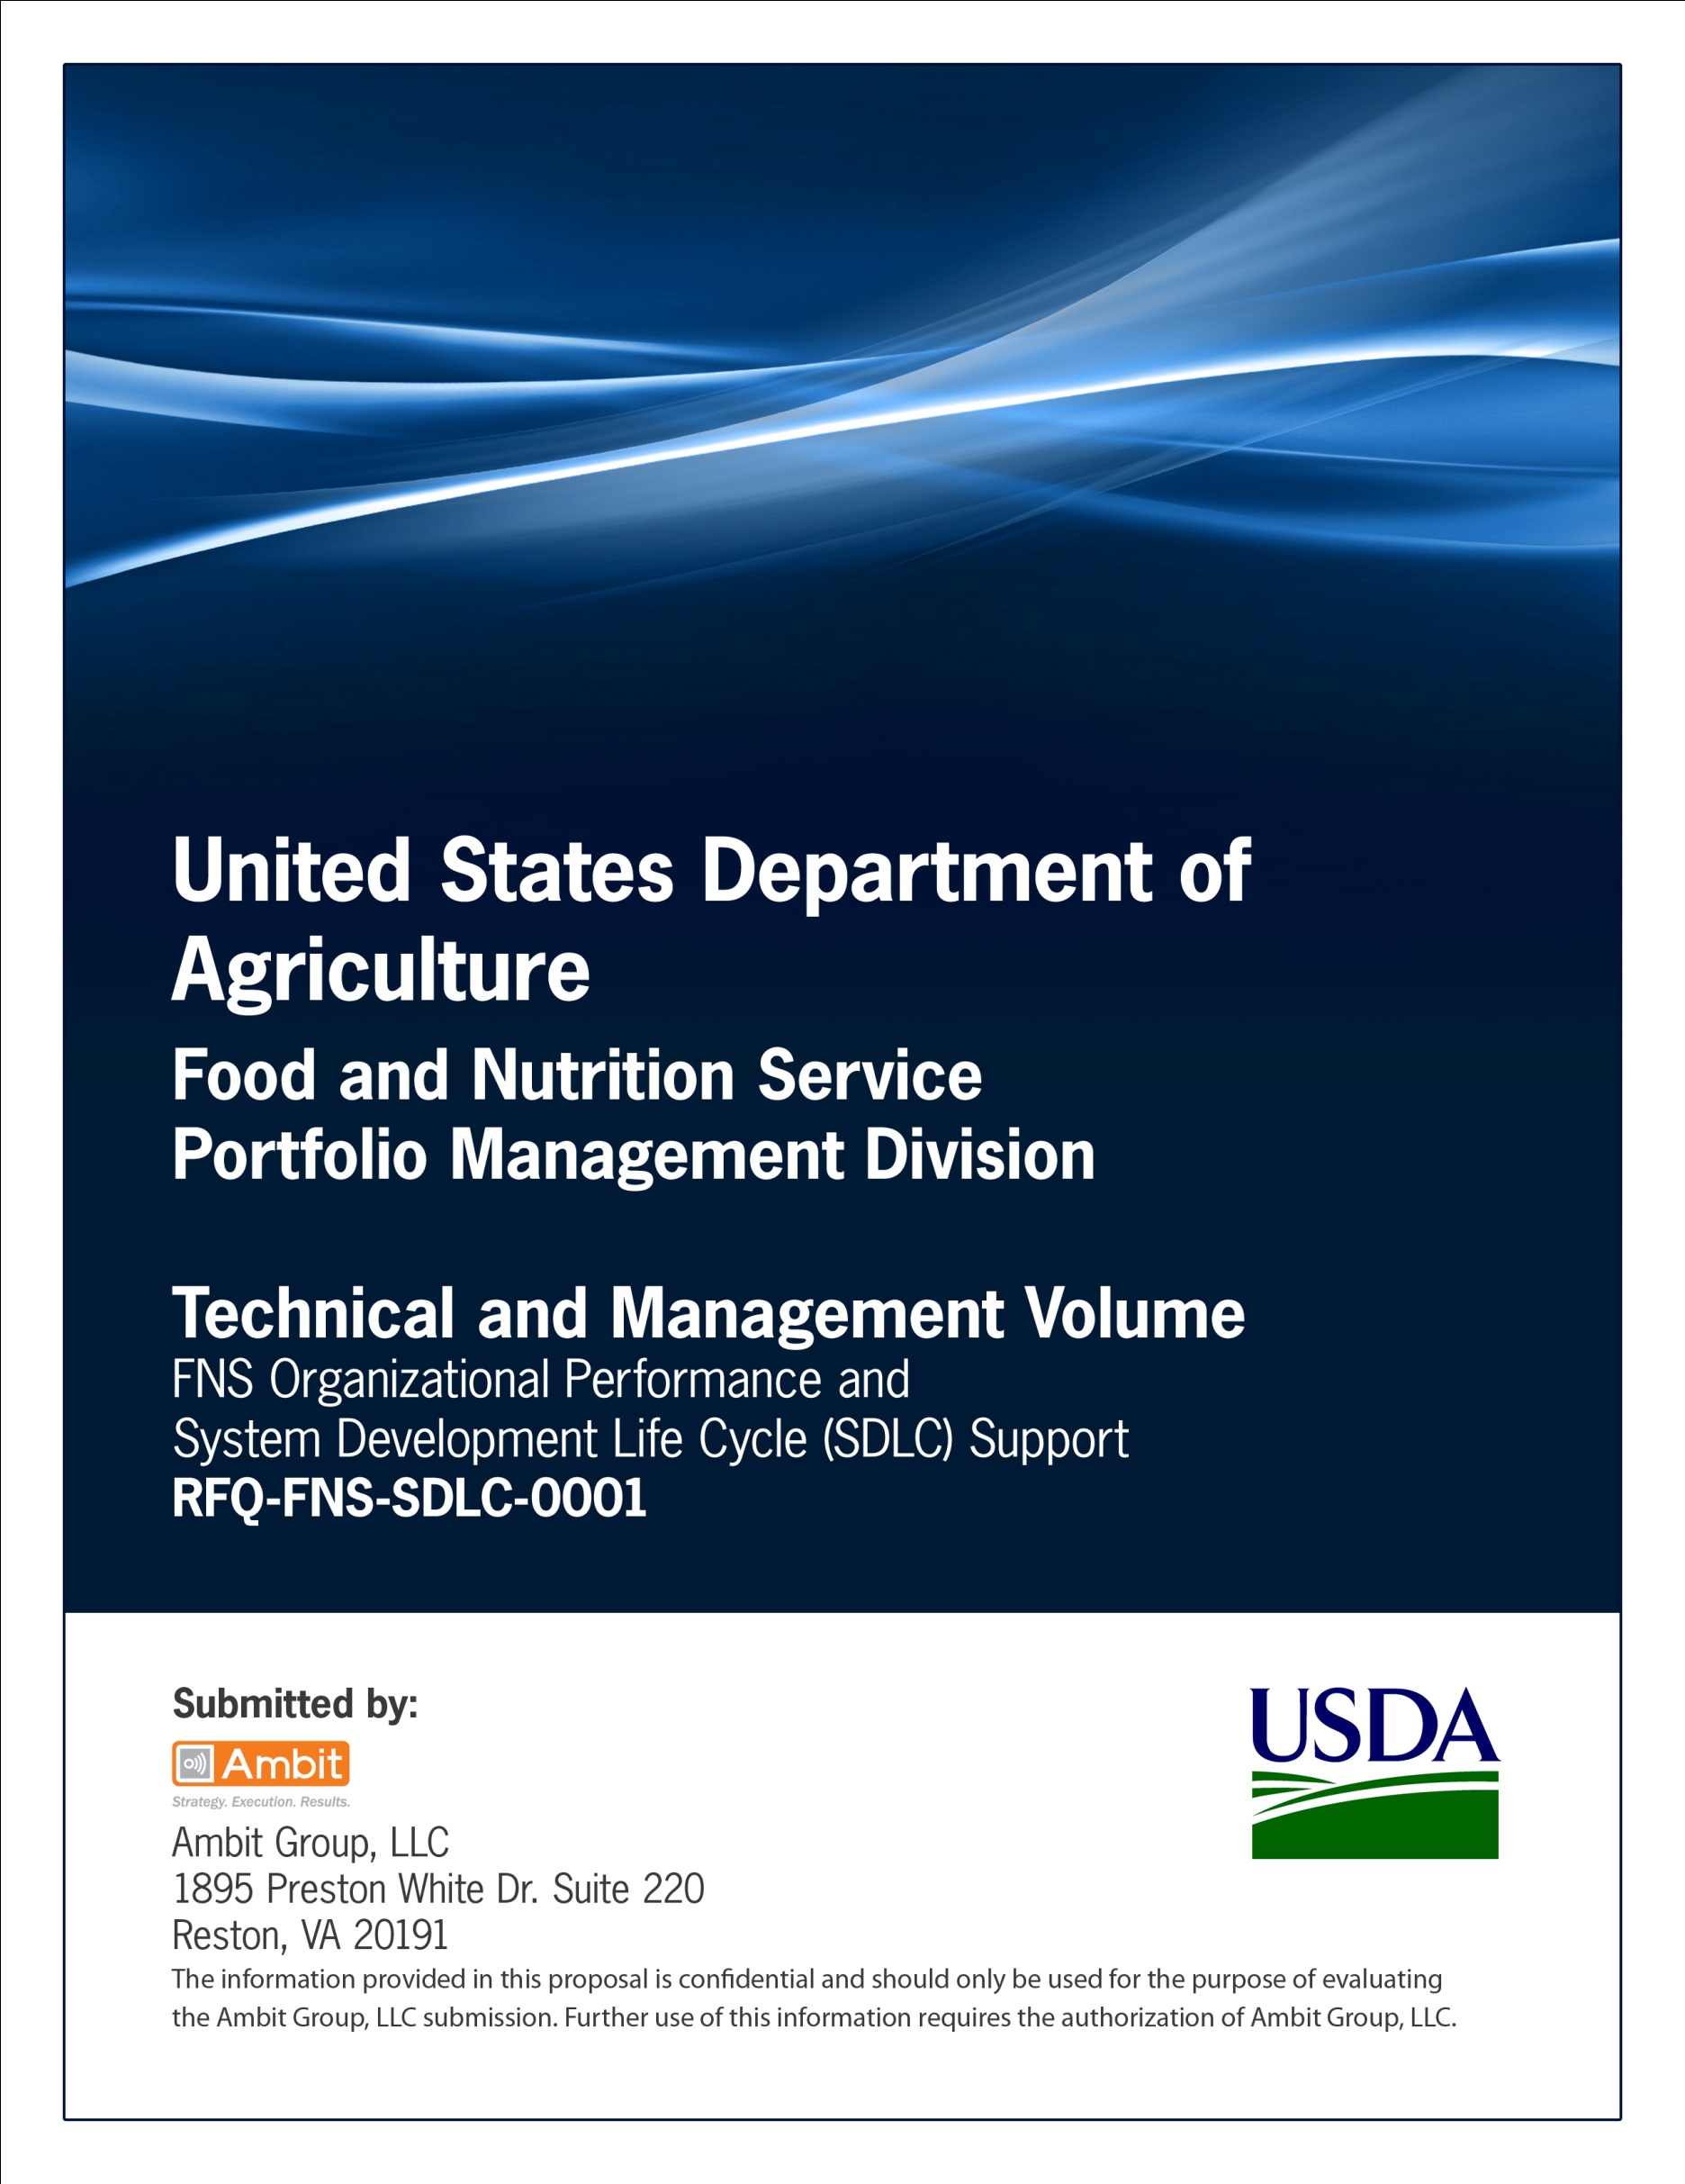

**FNS Office of Information Technology**

**Portfolio Management Division (PMD)**

**FNS Operations Readiness Template**

**for**

**[Project or System Name]**

**Version 1.1**

September 09, 2013

**Revision History**

|  |  |  |  |
| --- | --- | --- | --- |
| **Version** | **Date** | **Author** | **Change Description** |
| 1.0 | 03-18-2013 | IT Governance Branch (ITGB) | Created the document. |
| 1.1 | 09-09-2013 | IT Governance Branch (ITGB) | Re-formatted the document. |
| 1.2 |  |  |  |
| 1.3 |  |  |  |

**Contact Information**

|  |  |
| --- | --- |
| **Area of Concern** | **Contact Person** |
| IT Governance Lead | Kevin Russ |
| SDLC Coordinator | Syed Jaffery |
| ITIRB Coordinator | Sunny Dilawari |
| Portfolio Management Division Director, Chief Portfolio Officer | Jacqueline Butler |
| Program Management Branch Chief | Allison Willcox |

Contents

Glossary 4

1. Purpose 5

1.1. Project Identification 5

1.2. Project Overview 5

1.3. Software Application/System Interdependencies 5

1.4. Release Plan and Schedules Defined 6

1.5. Risk Mitigation and Contingency Plan 6

1.6. Readiness Review Checklist 6

Appendix A: References 8

Approvals/Signatures 9

# Glossary

| **Acronym** | **Description** |
| --- | --- |
|  |  |
|  |  |
|  |  |
|  |  |
|  |  |
|  |  |
|  |  |
|  |  |

# Purpose

The purpose of the Readiness Review is to ensure that the project has followed a defined software development process, and that the project team has identified any system interdependencies and risks that may have an adverse impact on the organization, and/or the software application/system deployment. The Readiness Review also confirms that appropriate departments have been notified and are fully aware of all pending releases and the potential impact. In this document, risk mitigation strategies and contingency plans are also defined, to help eliminate any adverse impact that may result from the release.

A Release Readiness meeting should be conducted to review the deployment plan using this document as a guide. Participants for the Release Readiness meeting should include a representative from all impacted areas.

## Project Identification

| **Project Identification** | | |
| --- | --- | --- |
| Project Name or Application Name | Project Number | Date Created |
| List the name of the project. | List the Project Number). | List the date. |
| Business Sponsor | Project Manager | |
| List the business owner. | List the project manager. | |
| Completed by | | |
|  | | |

## Project Overview

| **Project Overview** | |
| --- | --- |
| **Description** | |
| Provide a brief description of the project, the software application/system, and the planned deployment approach. This information is available from the Project Initiation Document, Software Requirements Specification and/or the Deployment Strategy and Plan. | |
| **Type of Release** | |
| Beta Release | |
| General Release | |
| Exception | |
| Other | Provide explanation if “Other” is selected. |

## Software Application/System Interdependencies

| **Software Application/System Interdependencies** |
| --- |
| **System Interdependency** |
| Identify the interdependent system. Identify any systems, software applications, data sources, files, etc. that may be affected by the installation of the new or changed software application/system. |
| **Potential Impact** |
| Identify the potential impact. Potential impacts may be to the system, process, or its inputs and outputs including updates, reports, replication, performance, etc. Identify the potential impact to the affected system as a result of deploying the new or changed software application/system. |
| **Person to Notify** |
| Identify the person to notify of the planned installation. Identify the affected person (responsible individual) who should be notified of the intent to deploy the new or changed software application/system. |
| **Notification Date** |
| Document the date. Document the date that the affected person (assigned to the interdependent system) was notified of the intent to install the new or changed software application/system. |

## Release Plan and Schedules Defined

| **Release Plan and Schedules defined** |
| --- |
| Identify both what will be released and the schedule for the release. Include the release procedures. |

## Risk Mitigation and Contingency Plan

| **Risk Mitigation and Contingency Plan** |
| --- |
| **Deployment Risk** |
| Identify any risks to the organization, systems, or other related entities that may develop as part of the release. |
| **Potential Impact** |
| Identify the potential impact. |
| **Risk Mitigation or Contingency Plan** |
| Identify a mitigation risk strategy or contingency plan for reducing or eliminating the risk. |

## Readiness Review Checklist

| **Readiness Review Checklist** | | | | |
| --- | --- | --- | --- | --- |
| Testing | **Yes** | **No** | **N/A** | **Comments** |
| 1. Have all walkthroughs, peer reviews, and management reviews been performed throughout the project? |  |  |  |  |
| 1. Has all formal testing been completed including unit, integration, and system tests? |  |  |  |  |
| 1. Have all interfaces been tested? (Note: not all interfaces may exist in any of the Test environments, but if the project relies on an untested interface, the risk needs to be identified along with recommendations to mitigate the risk.) |  |  |  |  |
| Documentation and Training | **Yes** | **No** | **N/A** | **Comments** |
| 1. Have training materials been completed for Operations, Support and end-users? |  |  |  |  |
| 1. Has training been scheduled for support staff, operations, and the client? |  |  |  |  |
| Software Configuration Management | **Yes** | **No** | **N/A** | **Comments** |
| 1. Have all required components been placed under control during development? (All files, including Executables, libraries and stored procedure files been placed under control.) |  |  |  |  |
| 1. Verify correct version of software has been tested and gone through all checkpoints listed above (unit, integration, user test). |  |  |  |  |
| 1. Notifications: Have all impacted parties been notified about the Release Plan and schedule? |  |  |  | Write in the names of those who have been notified |
| 1. Have all components been backed up and a recovery plan been defined? |  |  |  |  |
| 1. Has the post-production plan been established? This includes monitoring when the application goes into production. |  |  |  |  |

# Appendix A: References

Insert the name, version number, description, and physical location of any documents referenced in this document. Add rows to the table as necessary.

The following table summarizes the documents referenced in this document.

|  |  |  |
| --- | --- | --- |
| **Document Name** | **Description** | **Location** |
| Document Name and Version Number | Document description | URL or Network path where document is located |
|  |  |  |
|  |  |  |

# Approvals/Signatures

The undersigned acknowledge that they have reviewed the [name of document] document and agree with the information presented within this document. Changes to this document will be coordinated with, and approved by, the undersigned, or their designated representatives.

|  |  |  |  |
| --- | --- | --- | --- |
| Signature: |  | Date: |  |
| Print Name: |  |  |  |
| Title: |  |  |  |
| Role: | [Project or System Name] Project Manager |  |  |
|  |  |  |  |
| Signature: |  | Date: |  |
| Print Name: |  |  |  |
| Title: |  |  |  |
| Role: | [Project or System Name] Business Owner |  |  |
|  |  |  |  |
| Signature: |  | Date: |  |
| Print Name: |  |  |  |
| Title: |  |  |  |
| Role: | Organization’s Approving Authority |  |  |